Design and Implementation of a Five-Stage Pipelined RV32IM RISC-V Processor
Abstract This paper presents the architectural design, implementation, and functional verification of a five-stage pipelined RISC-V processor. The design is an evolution of a previously implemented single-cycle RV32IM processor featuring a custom Multiply-Accumulate (MAC) accelerator. To improve processor throughput and instruction-level parallelism, the sequential execution model was transitioned into a classic five-stage pipeline. Structural modifications include the introduction of inter-stage pipeline registers, data forwarding mechanisms, and hazard detection logic to manage load-use stalls and branch flushing. The modified design successfully preserves the baseline RV32I, RV32M, and custom MAC instruction behaviours while operating under a pipelined timing model. Final behavioural simulations confirm full functional accuracy, with the testbench reporting 35 passed and 0 failed tests.

1. Introduction
The RISC-V instruction set architecture (ISA) offers a highly modular and extensible framework for custom processor design. In prior work, a fully functional single-cycle RV32IM processor was developed, integrating the base integer instruction set (RV32I), the multiply-divide extension (RV32M), and a custom MAC extension optimized for digital signal processing workloads.
While the single-cycle architecture simplified control logic by completing one instruction per clock cycle, it inherently limited the maximum operating frequency due to the lengthy critical path through the instruction memory, register file, ALU, and data memory.
To overcome this limitation, this paper outlines the conversion of the baseline single-cycle datapath into a five-stage pipelined architecture.
The pipelining technique allows multiple instructions to overlap in execution, significantly increasing the instruction throughput. This document details the conceptual and structural changes required to achieve this conversion, including the resolution of structural, data, and control hazards introduced by the overlapped execution model.

2. Existing Single-Cycle Processor Architecture
The baseline architecture consisted of a classical single-cycle RISC-V datapath. Every instruction—from fetch to writeback—was executed entirely within a single clock cycle.
The datapath integrated several core modules: a synchronous Program Counter (PC), a combinational Instruction Memory, a 32-register Register File, an Arithmetic Logic Unit (ALU), a Data Memory, and a custom MAC unit housing a dedicated 32-bit accumulator.
A purely combinational control unit was responsible for decoding the opcode, funct3, and funct7 fields, immediately propagating control signals (such as reg_write, alu_src, mem_read, and branch) to the datapath muxes and execution units without intermediate latching. While functionally robust, this sequential layout necessitated a clock period long enough to accommodate the worst-case instruction delay, such as a load word (LW) instruction.
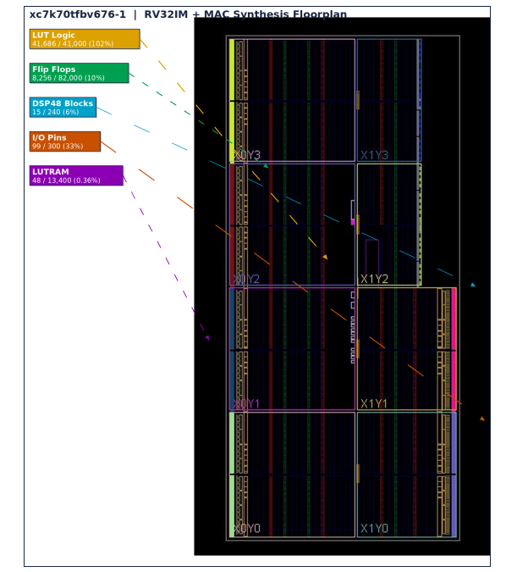
[Figure 1: Original Single-Cycle Processor Datapath] Caption: The baseline single-cycle RV32IM architecture, illustrating the immediate propagation of data and control signals from the instruction memory through the ALU and data memory in a single clock cycle.

3. Methodology / Design Implementation
The core conversion methodology involved partitioning the single-cycle datapath into five discrete, sequential stages. This required introducing synchronous boundary registers and comprehensive hazard resolution logic to ensure functional equivalence with the single-cycle model.

3.1 Proposed Five-Stage Pipeline Architecture
The processor's operations were segregated into the five classic RISC-V pipeline stages:
- Instruction Fetch (IF): The PC accesses the instruction memory to fetch the 32-bit instruction.
- Instruction Decode (ID): The instruction is parsed by the control unit. Source registers are read from the register file, and immediates are generated.
- Execute (EX): The ALU performs arithmetic/logic operations, resolves branch conditions, and computes memory addresses. The custom MAC operations are also executed here.
- Memory Access (MEM): Data memory is accessed for load or store instructions.
- Write Back (WB): The final result (from the ALU, MAC, or Data Memory) is written back to the destination register in the register file.
(Placeholder) [Figure 2: Proposed Five-Stage Pipeline Architecture] Caption: The modified datapath showing the integration of the five pipeline stages and intermediate registers.

3.2 Pipeline Register Design
To preserve instruction-specific data across clock boundaries, pipeline registers were instantiated between each stage:
- IF/ID Register: Captures the fetched instruction and the associated PC value.
- ID/EX Register: Stores the decoded control signals, register read data (rs1, rs2), sign-extended immediate values, and the destination register (rd) identifier.
- EX/MEM Register: Buffers the ALU result, memory write data, destination register (rd), and memory-stage control signals (e.g., mem_read, mem_write).
- MEM/WB Register: Holds the data retrieved from memory, the ALU/MAC result, and the writeback control signals (e.g., reg_write, mem_to_reg).

3.3 Control Signal Propagation
In the pipelined model, the central control unit remains in the ID stage. However, control signals are no longer applied instantly across the entire datapath.
Instead, they are bundled and propagated sequentially through the pipeline registers.
For example, mem_write is generated in ID, buffered in ID/EX, and finally utilized in the EX/MEM stage.
Furthermore, control logic was explicitly corrected to ensure AUIPC execution utilizes the PC of the specific instruction propagating through the EX stage, rather than the global, currently fetching PC.

3.4 Hazard Handling Logic
The introduction of overlapped execution necessitated specialized hazard detection and resolution hardware.
- Data Forwarding: Data hazards occur when an instruction requires the result of a preceding instruction that has not yet reached the Write Back stage.
Forwarding paths were added to route data directly from the EX/MEM and MEM/WB registers back to the ALU inputs in the EX stage. Forwarding signals (such as forward_a and forward_b) intelligently select the most recent valid data, bypassing the register file and eliminating unnecessary stalls.
- Load-Use Stall: A specific hazard arises when an instruction immediately follows a load (LW) that targets one of its source registers.
Because the loaded data is only available after the MEM stage, forwarding alone is insufficient.
A hazard detection unit was introduced in the ID stage to detect load-use dependencies and stall the pipeline, inserting a single-cycle "bubble" (a NOP) while disabling the PC and IF/ID register updates.
- Branch and Jump Flushing: In this implementation, branch and jump outcomes are resolved in the Execute stage.
If a branch is taken or a jump is executed, the instructions already fetched into the IF and ID stages are incorrect.
The processor issues a flush signal, clearing the IF/ID and ID/EX pipeline registers, effectively discarding the speculative instructions and redirecting the PC to the correct target.

3.5 Register File Timing Improvement
To resolve same-cycle structural hazards during the Write Back and Decode stages, the register file was upgraded.
The timing model was modified to support writeback-read consistency (write-before-read), allowing an instruction in the ID stage to immediately read data that is being concurrently written back by an instruction in the WB stage.

4. Simulation and Results
The updated pipelined processor was simulated using the Vivado XSim behavioural simulator.
Because the pipelined architecture relies on overlapping operations, it takes multiple clock cycles to fill the pipeline before the first instruction commits, and subsequent cycles to drain the pipeline after the final instruction. Consequently, the top-level testbench simulation cycle count was adjusted to account for this inherent pipeline latency.
Simulation waveforms validate the delayed progression of instructions through the pipeline.
Signals such as if_id_pc, id_ex_pc, and ex_mem_rd correctly indicate the sequential flow of state across boundaries.
The functional impact of hazard logic is also clearly observable, with stall, flush, and forwarding signals correctly asserting under appropriate conditions.
The processor was verified using the same comprehensive 60-instruction test program utilized in the single-cycle design, which includes R-type and immediate ALUs, memory operations, branch/jump targets, the RV32M multiplier/divider, and custom MAC operations.
The final testbench results confirm complete functional parity with the non-pipelined baseline, reporting a perfect score of 35 passed assertions and 0 failures.
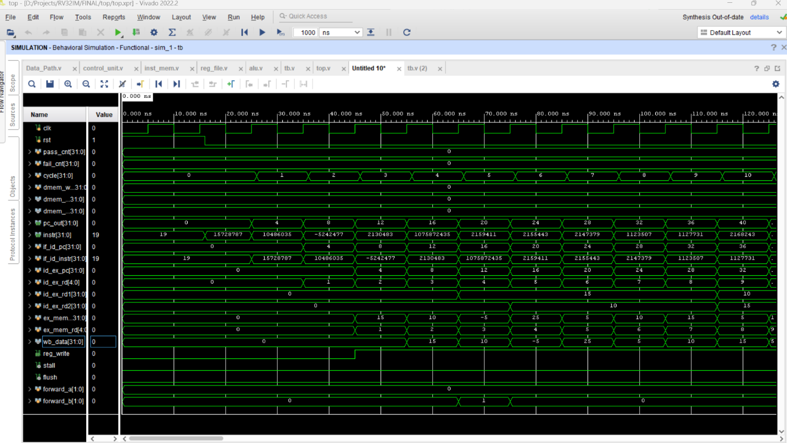
[Figure 2: Pipeline Timing Diagram] Caption: Conceptual timing diagram illustrating the overlapped execution of instructions and the resolution of a sample load-use hazard.

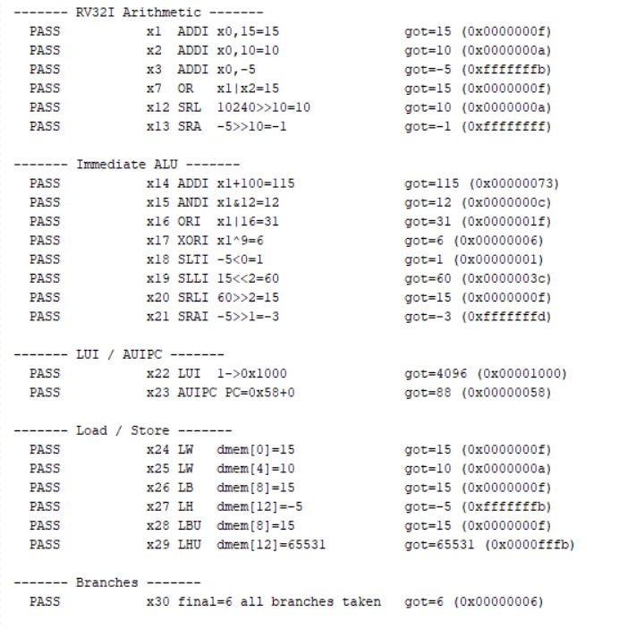
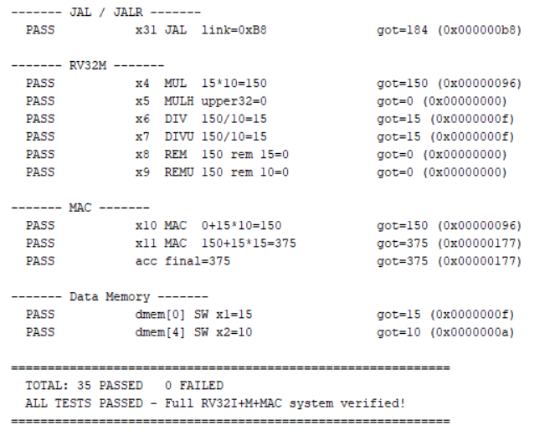
[Figure 3: Simulation Result Showing 35 Passed and 0 Failed] Caption: TCL console output confirming the success of all 35 architectural validation tests on the newly pipelined design.

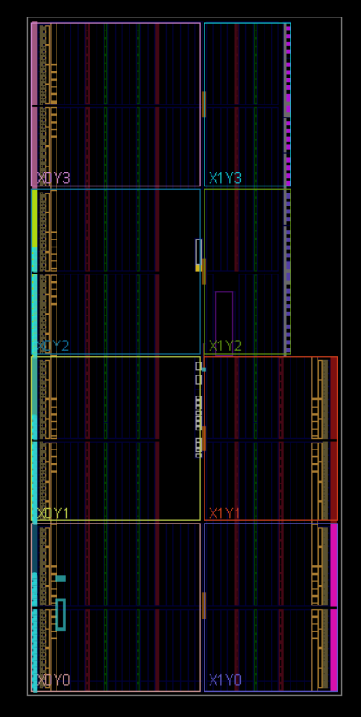

[Figure 4: Floorplan view of the synthesized RV32I processor implemented on the Xilinx FPGA.] The floorplan shows the distribution of logic resources including LUTs, Flip-Flops, DSP blocks, I/O pins, and LUTRAM across the FPGA fabric. Resource placement is spread throughout the available clock regions to achieve efficient utilization and routing performance.

5. Discussion
Converting the architecture from single-cycle to pipelined involved significant structural overhead, most notably the wide inter-stage registers and multiplexing logic for forwarding.
Despite this added complexity, the processor successfully isolates operations to distinct stages.
The successful passing of all test cases—specifically for the custom MAC instructions and complex RV32M divide operations—demonstrates that the architectural changes strictly altered the timing and flow of data without breaking the underlying logic.
The top-level interface was thoroughly cleaned up to provide high simulation visibility into internal registers, confirming that same-cycle writebacks and multi-cycle stalls trigger seamlessly.

6. Conclusion
A single-cycle RV32IM processor with a custom MAC extension has been successfully converted into a formal five-stage pipelined architecture.
By implementing essential pipeline boundary registers alongside sophisticated hazard resolution units—including bypass forwarding, load-use stall insertion, and control flow flushing—instruction throughput potential has been vastly improved.
Comprehensive testbench simulations confirm that the intricate timing adjustments do not compromise architectural correctness, perfectly preserving all base and extended RISC-V behaviours.
GIT Rep: https://github.com/AKSHAY-SV/RV32IM-with-5-stage-pipeline.git

